PBMC Staining Protocol - Fresh

Materials:
- Staining Buffer: DPBS + 5% FBS
- FcBlock: BD Cat# 564219
- Ab Cocktail: Keep on ice, in dark until use. For multiple BV dyes, use BD Brilliant Staining Buffer.
- 96 well plate: Round bottom preferred. Flat bottom also works.
- 7-AAD: Biolegend Cat# 420403
Method:
The staining is for 96 well plate, you can use larger washing volume for tubes.
0.5 million unstained cells, just go through the same incubation time and centrifuge, fixation.
- 1 million PBMC in 100 ul Staining Buffer.
- Add 1 uL FcBlock, mix, incubate for 10 min on ice.
- Add 50 uL Ab Cocktail, gentle mix, 15 min on ice in dark.
- Add 100 uL Staining Buffer, gentle mix
- 300xg, 5 min. Flip to remove supernatant. Resuspend in 200 uL Staining Buffer.
- Add 2 uL 7-AAD 15 min before flow acquisition.
Note:
To remove antibody aggregates, 15,000 g for 5 min, take supernatant.
For cell sorting, use DPBS + 1% BSA for staining buffer. 1 mM EDTA optional.

Tubes for cytometer:
Falcon 12x75mm tube, no cap Cat# 352008; Snap cap (sterile) Cat# 352054
If there are clumps, filter using Falcon 5 ml tube with strainer cap (Cat# 352235).
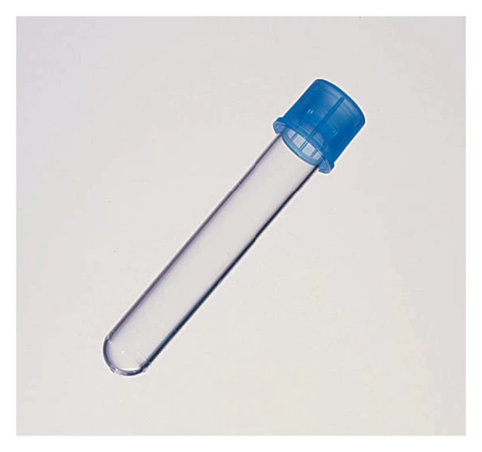

PBMC Staining Protocol + Fixation

Materials:
- Staining Buffer: DPBS + 5% FBS
- Zombie NIR: Keep frozen until use. Made in 100 uL DMSO. Dilute 1:100 again in DMSO.
- FcBlock: BD Cat# 564219
- Ab Cocktail: Keep on ice, in dark until use. For multiple BV dyes, use BD Brilliant Staining Buffer.
- Fix Buffer: Biolegend brown bottle Cat# 420801. Bring to room temperature before use.
- 96 well plate: Round bottom preferred. Flat bottom also works.

Method:
The staining is for 96 well plate, you can use larger washing volume for tubes.
0.5 million unstained cells, just go through the same incubation time and centrifuge, fixation.
- 1 million PBMC in ~200 ul DPBS. This is NOT staining buffer, no protein allowed.
- Add 2 uL Zombie NIR live/dead staining, mix immediately. 15 min in dark, room temperature.
- Add 70 uL Staining Buffer (less than overfill the wells), gentle mix.
- 300 x g, 5 min, flip to remove supernatant, add 1 uL FcBlock, mix, incubate for 10 min on ice.
- Add 50 uL Ab Cocktail, gentle mix, 15 min on ice in dark.
- Add 200 uL Staining Buffer, gentle mix
- 300xg, 5 min. Remove supernatant. Resuspend in 100 ul Fixation Buffer or > 2 x pellet vol, mix. 40-60 min in dark at room temp.
- Add 100 uL Staining Buffer, gentle mix, centrifuge. Resuspend in 200 uL Staining Buffer.

