LSR II Cleaning Procedure
BD stops the service contract. Repair visit costs $3000 labor plus parts. Cleaning is the key to avoid problems. Please perform the cleaning procedure after your experiment, and wash as much as you can before experiment.
- On Standby, load a tube with bleach with the sample stage arm open for 1 min.
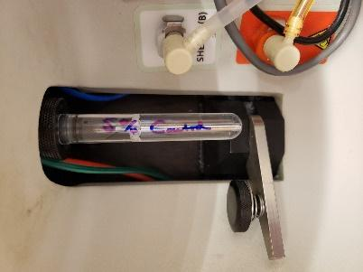

- Run bleach on HIGH with the stage arm closed for 5 min.

- Water. Open arm 1 min, close arm on run 1 min.

- Contrad. Open arm 1 min, close arm on run 5 min.

- Water. Close arm on run 1 min.

- Standby. Leave tube on with no more than 0.5 mL of water.
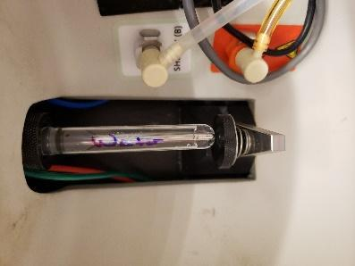

Note:
Important to have water between bleach and contrad because these two can form sticky stuff.
Do not run too concentrated samples. Filter if cells are clumpy.
Filter tubes: Falcon 5 mL tubes (cat# 352235).
Regular FACS tube: Falcon 12x75mm, no cap Cat# 352008; snap cap Cat# 352054

