A Common Stomach Bug Has Become Harder to Treat

A growing share of shigella infections are drug-resistant, the C.D.C. warns in a new report.

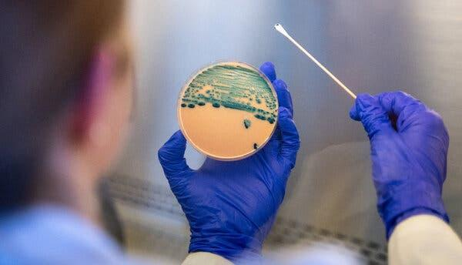


By Catherine Pearson
April 24, 2026

Infections caused by drug-resistant shigella — a diarrhea-causing bacteria — have increased in recent years, a Centers for Disease Control and Prevention report has warned.

These strains, which are called extensively drug-resistant, or XDR, do not respond to the five antibiotics that have traditionally been used to treat more serious cases.

In 2011, no shigella infections in the United States were identified as being drug-resistant; by 2023, XDR strains accounted for 8.5 percent of all shigella infections. XDR shigella was first identified in the United States a decade ago.

“Historically, the infection was reasonably easy to treat in the small proportion of people for whom antibiotics were needed,” said Dr. Judith O’Donnell, chief of the infectious diseases division at Penn Presbyterian Medical Center. “But,” she added, “we are now seeing a real change, or an evolution, in that bacteria in terms of its resistance genes.”

Still, infectious disease experts and epidemiologists say it is important to maintain perspective given that less than 10 percent of cases are drug-resistant. The C.D.C. estimates that shigella causes around 450,000 infections in the United States each year.

“Obviously, it’s really concerning that the rates of extensively drug-resistant shigella are rising so quickly,” said Dr. Patrick Kenney, a clinical assistant professor of pediatrics in the Jacobs School of Medicine and Biomedical Sciences at the University at Buffalo. “But the vast majority of folks will get better on their own.”

Understanding Shigella

The bacteria cause an infection called shigellosis, which tends to be relatively mild and clears without antibiotics within a week or so with rest and fluids. The primary symptom is diarrhea.

But some patients may experience illness that “can be pretty debilitating,” said Dr. Wilbur Chen, an infectious disease physician and scientist with the University of Maryland School of Medicine. Their symptoms can including bloody stool, prolonged diarrhea that lasts more than three days and severe cramping. In those cases, an antibiotic may be prescribed.

Unfortunately, it doesn’t take many bacteria to pass along shigella, Dr. Chen said, so it can easily spread from person to person.

Though infection is possible at any age, children under 5 are at the highest risk — as is often the case for bacteria that spread via the fecal-oral route. For instance, an infected child who did not wash his or her hands after using the bathroom may then transfer the bacteria to a classmate via a shared toy or doorknob.

People can also become sick if they eat food prepared by someone with an infection or swallow contaminated water while swimming.

In the new C.D.C. report, most drug-resistant shigella infections were among adult men. The agency did not examine sexual exposure data, but prior research has found that outbreaks can occur among men who have sex with men.

“There is a significant amount of sexual transmission of this that is probably going on,” said Dr. O’ Donnell, pointing to the importance of safer sex practices. “Patients need to be aware.”

Experts said measures like frequent hand washing and taking care not to swallow water in lakes or pools are among the best ways to prevent infection.

Looking Forward

Shigella is not the only bacteria that has become increasingly resistant to antibiotics.

A 2025 World Health Organization report found that globally, antimicrobial resistance — when bacteria, viruses, fungi or parasites resist the medications used to treat them — is increasing by as much as 15 percent per year.

“We do know that overuse of antibiotics is a very large driver of antibiotic resistance,” said Dr. Geeta Sood, an assistant professor of medicine and hospital epidemiologist at Johns Hopkins Bayview Medical Center.

Antimicrobial resistance is a natural process that happens over time, as microbes adapt in order to survive exposure to the medications designed to kill them. But unnecessary use or misuse of antibiotics can accelerate resistance. Germs find ways to mutate and survive and can spread resistance to other germs. Resistant infections can be difficult to treat.

Dr. Chen noted that because drug-resistant shigella is not treatable with common oral antibiotics, patients often require a “bigger gun antibiotic” in the hospital. (Nearly 40 percent of the cases described in the C.D.C. report led to hospitalization.) Oral and intravenous drug options do exist for those patients, but no optimal therapy has been established so far.

The new report analyzed data only through 2023, as federal data takes time to collect and analyze. Experts were loath to predict whether drug resistant infections may have worsened in the intervening years — but they were not optimistic.

“The trend for almost all of these infections tends to be increasing rates of resistance,” Dr. Sood said. “If I were a betting person, I would be betting that we would be seeing increasing rates of XDR shigella.”

Catherine Pearson is a Times reporter who writes about families and relationships.

