

NigeriaQual TB Software
USER MANUAL
The NigeriaQual Software
The NigeriaQual TB software is a bespoke application built for quality improvement in the Nigerian tuberculosis space. The application routinely collects patient-level data in different evaluation areas and generates reports, which can be used to make informed decisions by various stakeholders. Username and password will be shared with authorized users.

Getting Started
- To log in to the software, enter log-in details as shown below:
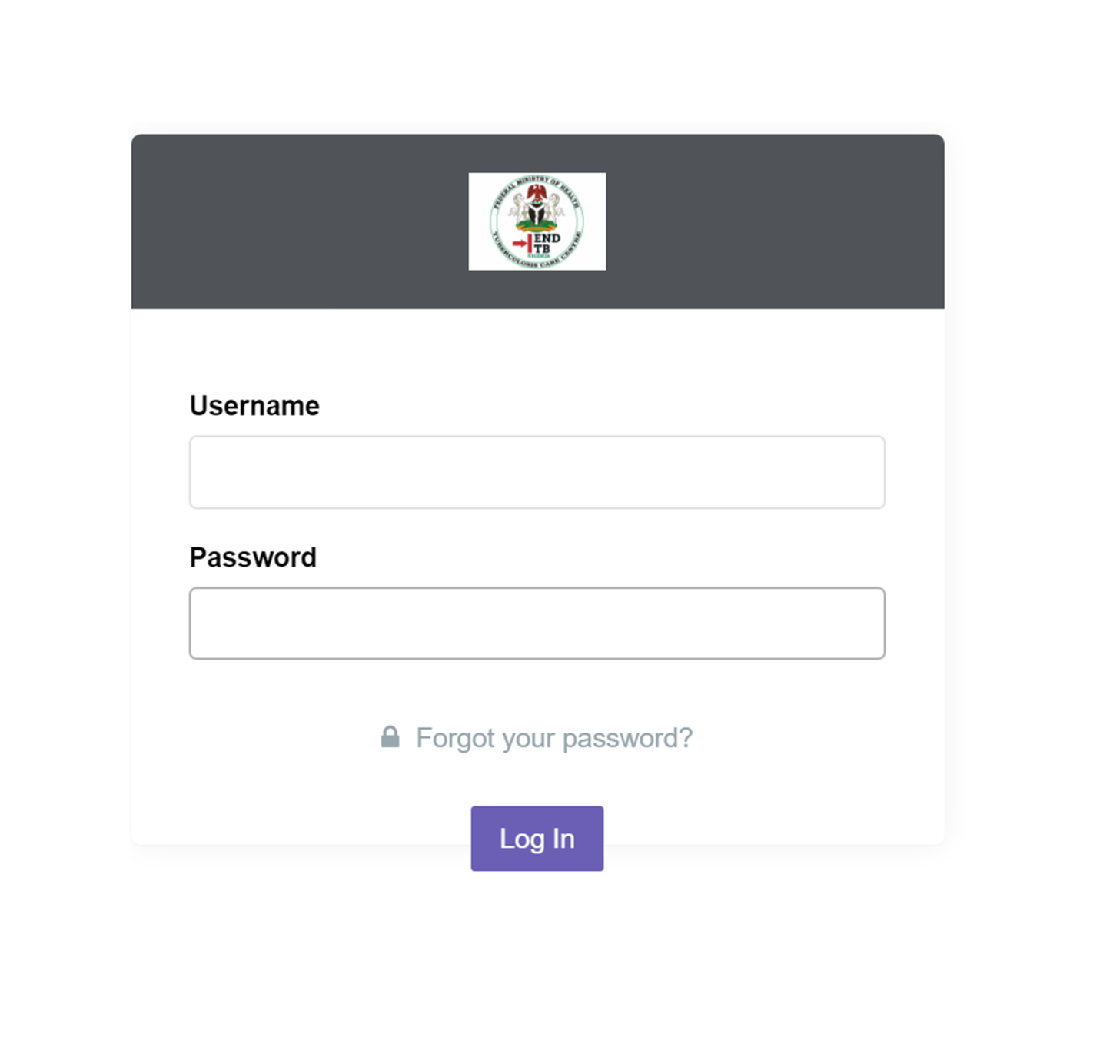

- To enter facility details, start by typing in the facility code in the text box provided.
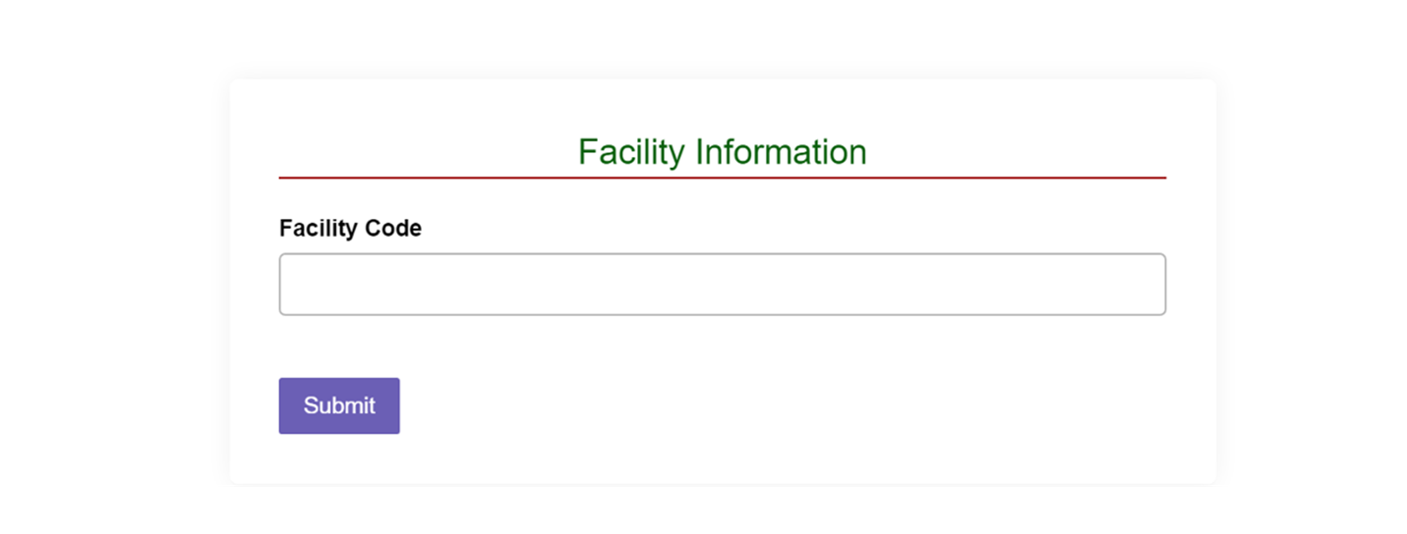
3. Click on the “Submit” button.
4. After entering the facility code, the facility information automatically populates into the appropriate text boxes.
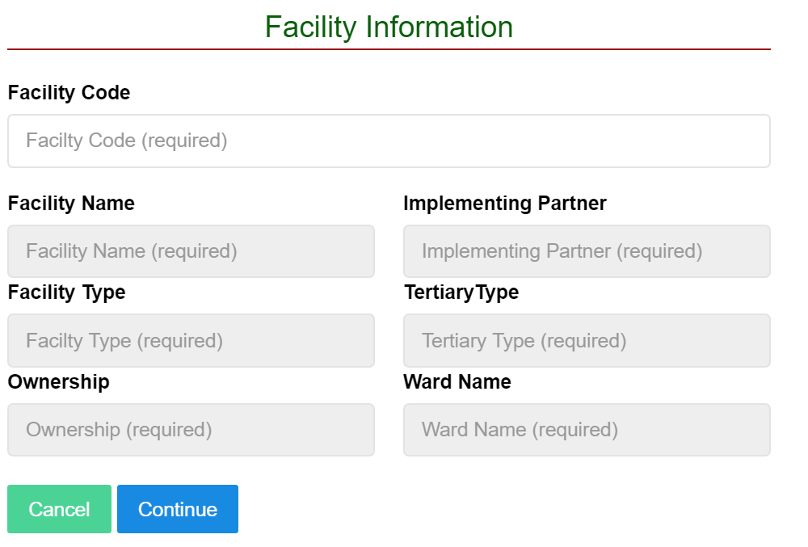

5. Click on “Continue” to proceed to the next page.
On the page that appears, three tabs are available: “Create User,” “Manage User,” and “Dashboard.”
The “Create Users” tab is used to create all users who will be accessing the system (i.e., system users).
The “Manage Users” tab is used to manage all existing users.
The “Dashboard” shows all the functionalities and capabilities of the system.
CREATING USERS
This page helps to create or grant access to new users. To create new users:
- Click on the “Create User” tab to setup the profile information of the user. Fill in the appropriate information in the spaces provided.
- Select the role for the user created.

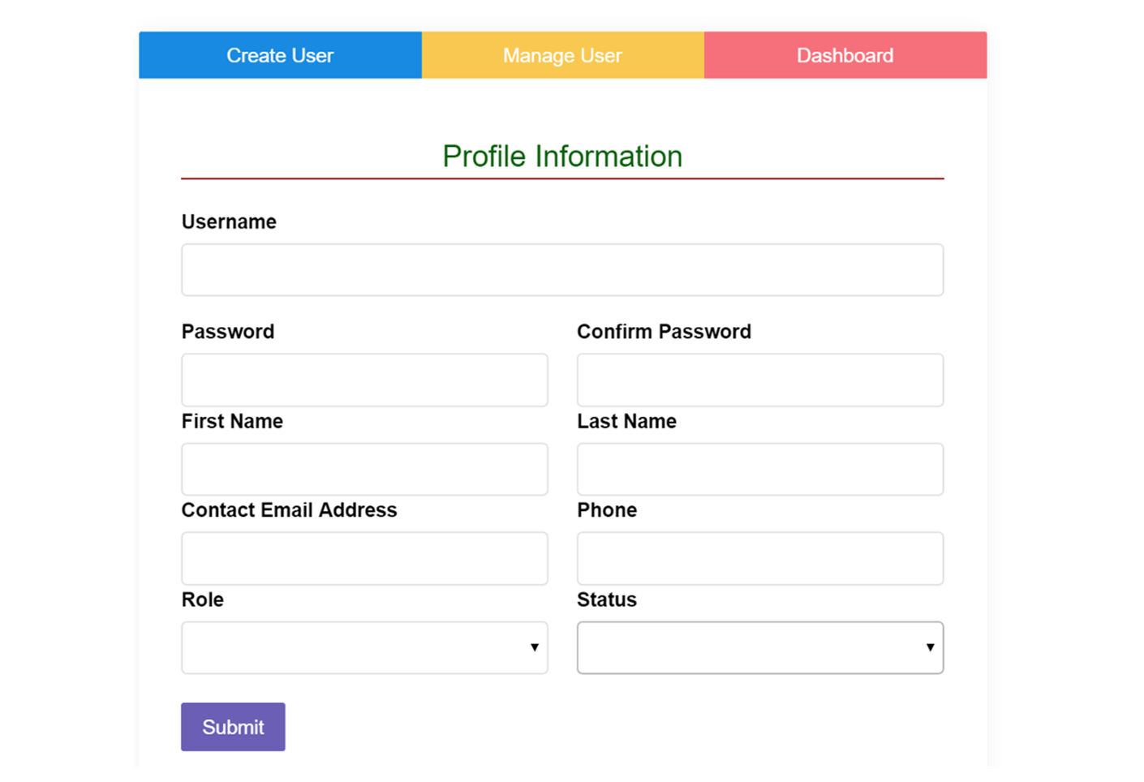
Note: In the “Role” text box, there are four types of users:
- Data Entry: A user with this role can only enter data into the system. He/she has no ability to perform any other function other than this.
- Power User: A power user has ability to capture data and view reports in the system. Other than this, they can’t perform any other functions.
- Report User: This user can only view reports for data captured in the system.
- Administrator: The admin user has the ability to do all of the above, as well as perform other actions such as data upload, create a new review period, and create other users.
3.) Select a “Status” for the user.
4.) Click the “Submit” button.
The assessment page appears next. Available on this page are three tabs named “Create Review,” “View Review,” and “Dashboard.” Essentially, this page helps to set the review period date and the details of the assessor. To fill in the assessment page, do the following:
- On the page with the title “Assessment Information,” enter all necessary data in the appropriate text boxes.

NOTE: “Date of assessment” MUST NOT be any day before the beginning of the review period. If a day before the beginning of the review period is entered, the “Submit” button will be invisible.
- Click the “Submit” button.
- Click on the “Dashboard” tab to access the evaluation areas.
DRUG SUSCEPTIBLE TUBERCULOSIS (DS_TB) EVALUATION AREA
To access the DS_TB Evaluation area on the dashboard such as the one below:
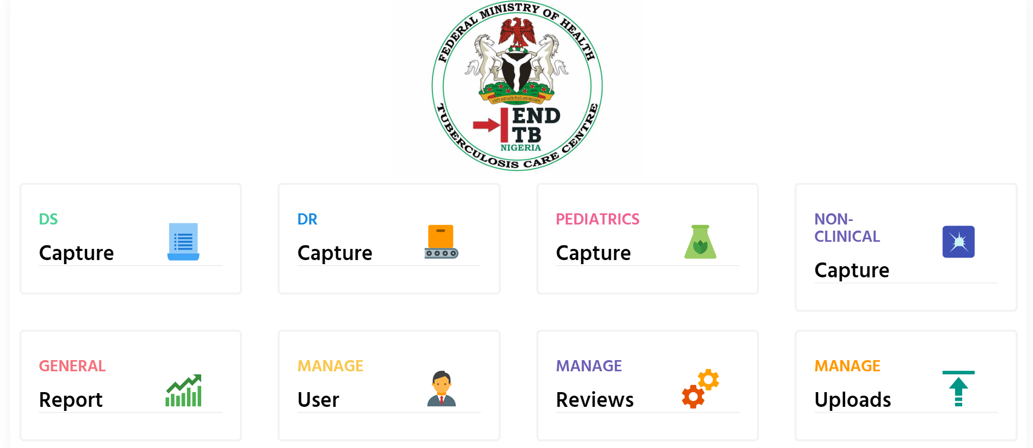

- Click on the “DS Capture” icon and the DS_TB evaluation area appears.
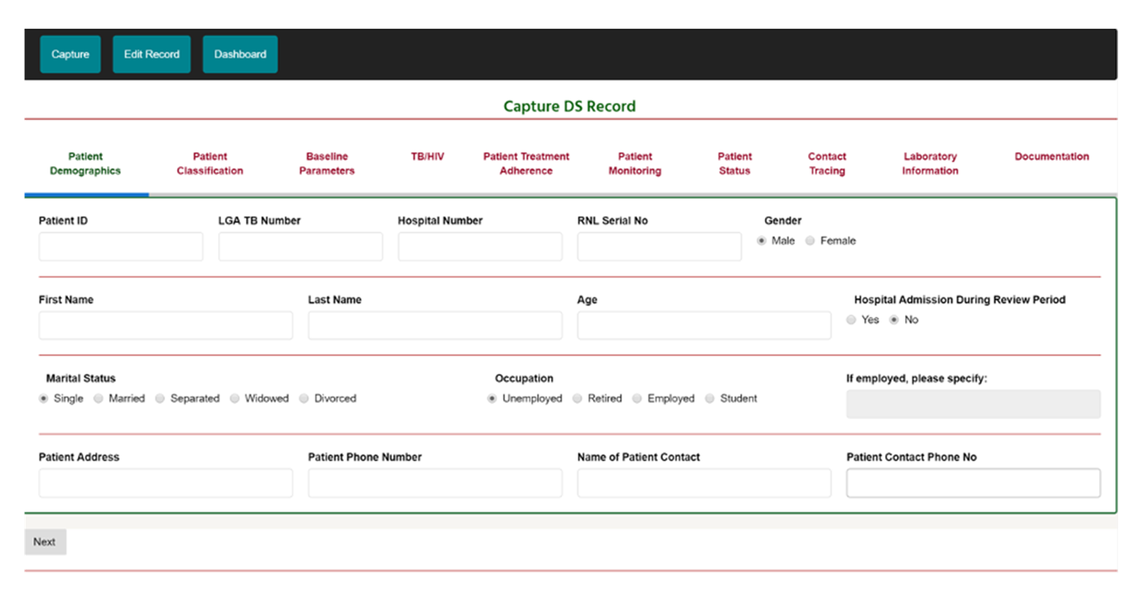
- Enter data into all fields in the Patient Demographics tab and click “Next” to move to the next tab.
Please Note: All fields are required EXCEPT hospital number, RNL serial number, patient phone number, and patient address. If mandatory fields are not filled, you can’t proceed to the next page.
- On clicking the “Next” button, the Patient Classification tab is activated. All categories in this tab are required to continue.
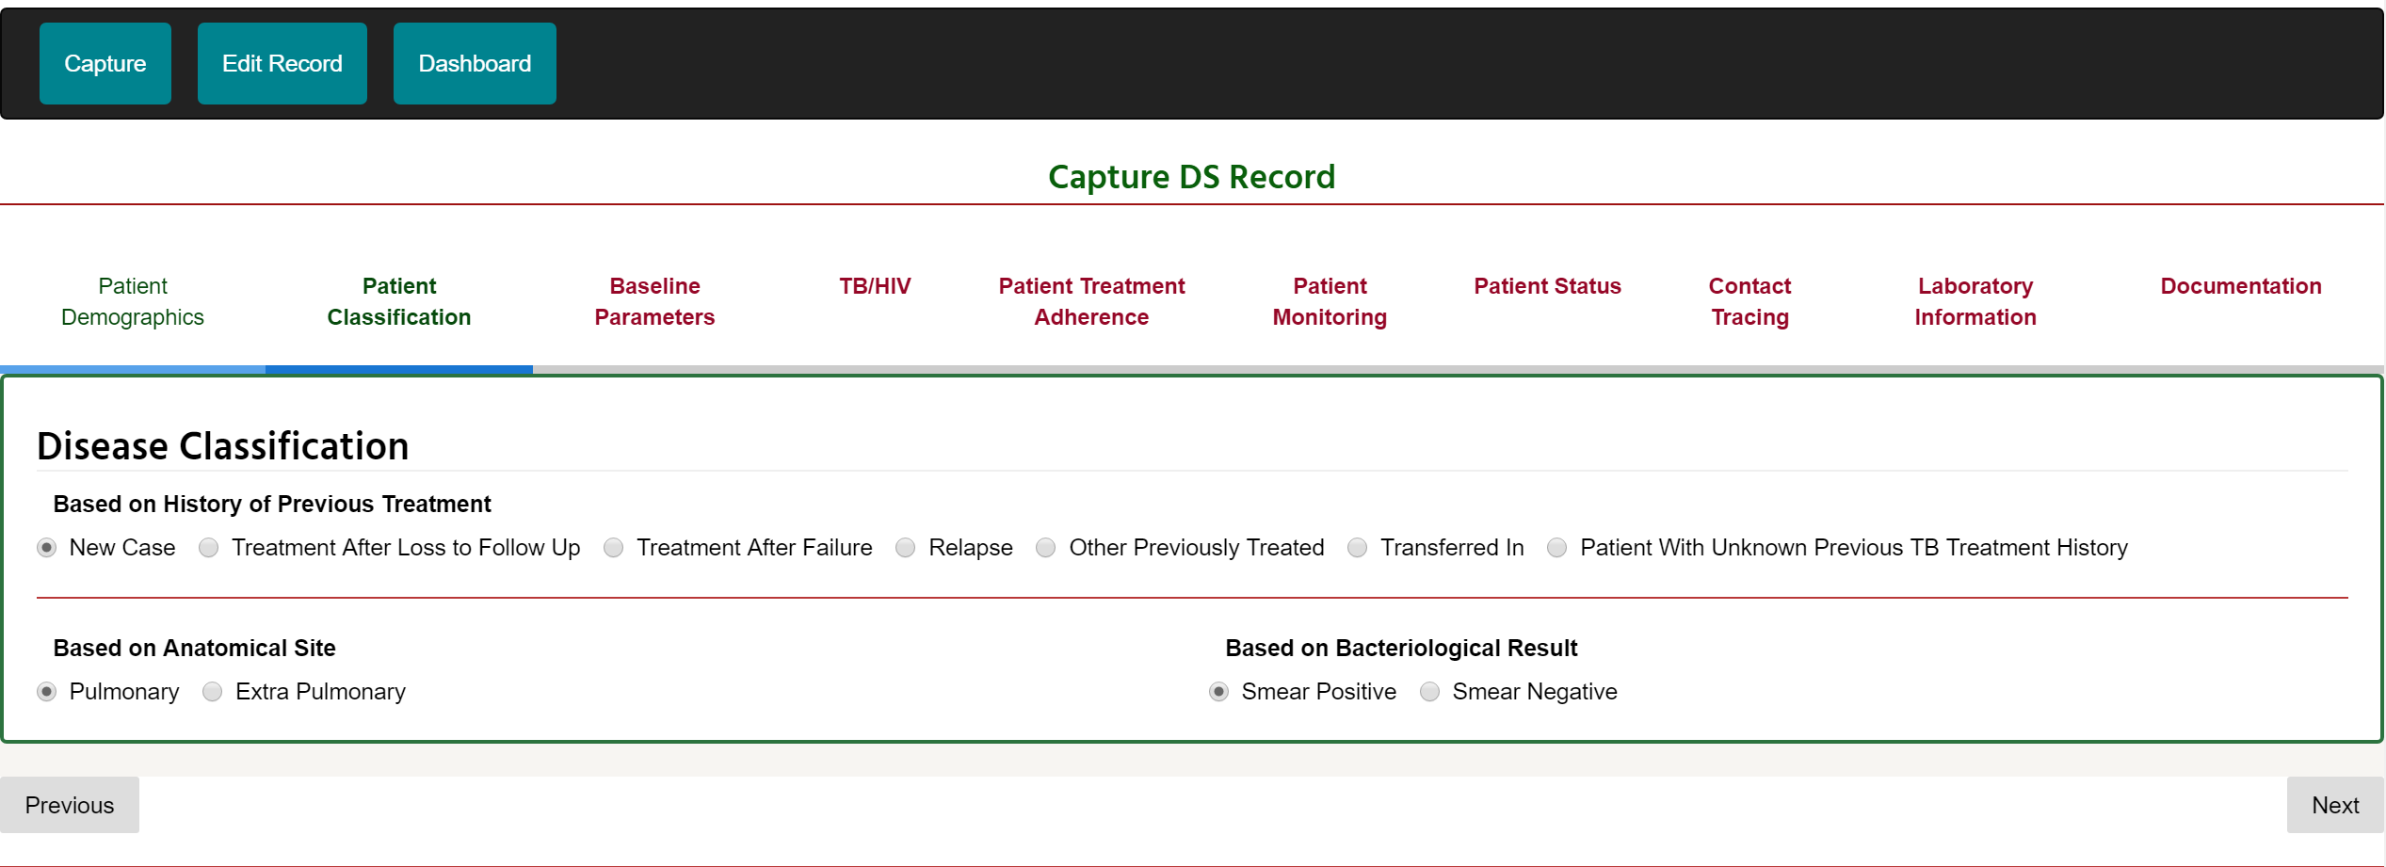
The “Previous” or “Next” button allows you to navigate to the preceding or succeeding tab, respectively.

- The “Baseline Parameters” tab also requires an option to be selected in each of the categories to proceed to the next Tab. In the “Patient Diagnosis” category, if the “Yes ” option is selected for “AFB Smear Microscopy Test Done,” then the fields of “GeneXpert test done,” “was the patient sputum sample collected,” “date test done,” “result,” and “date result released” must be selected to proceed to the next tab.
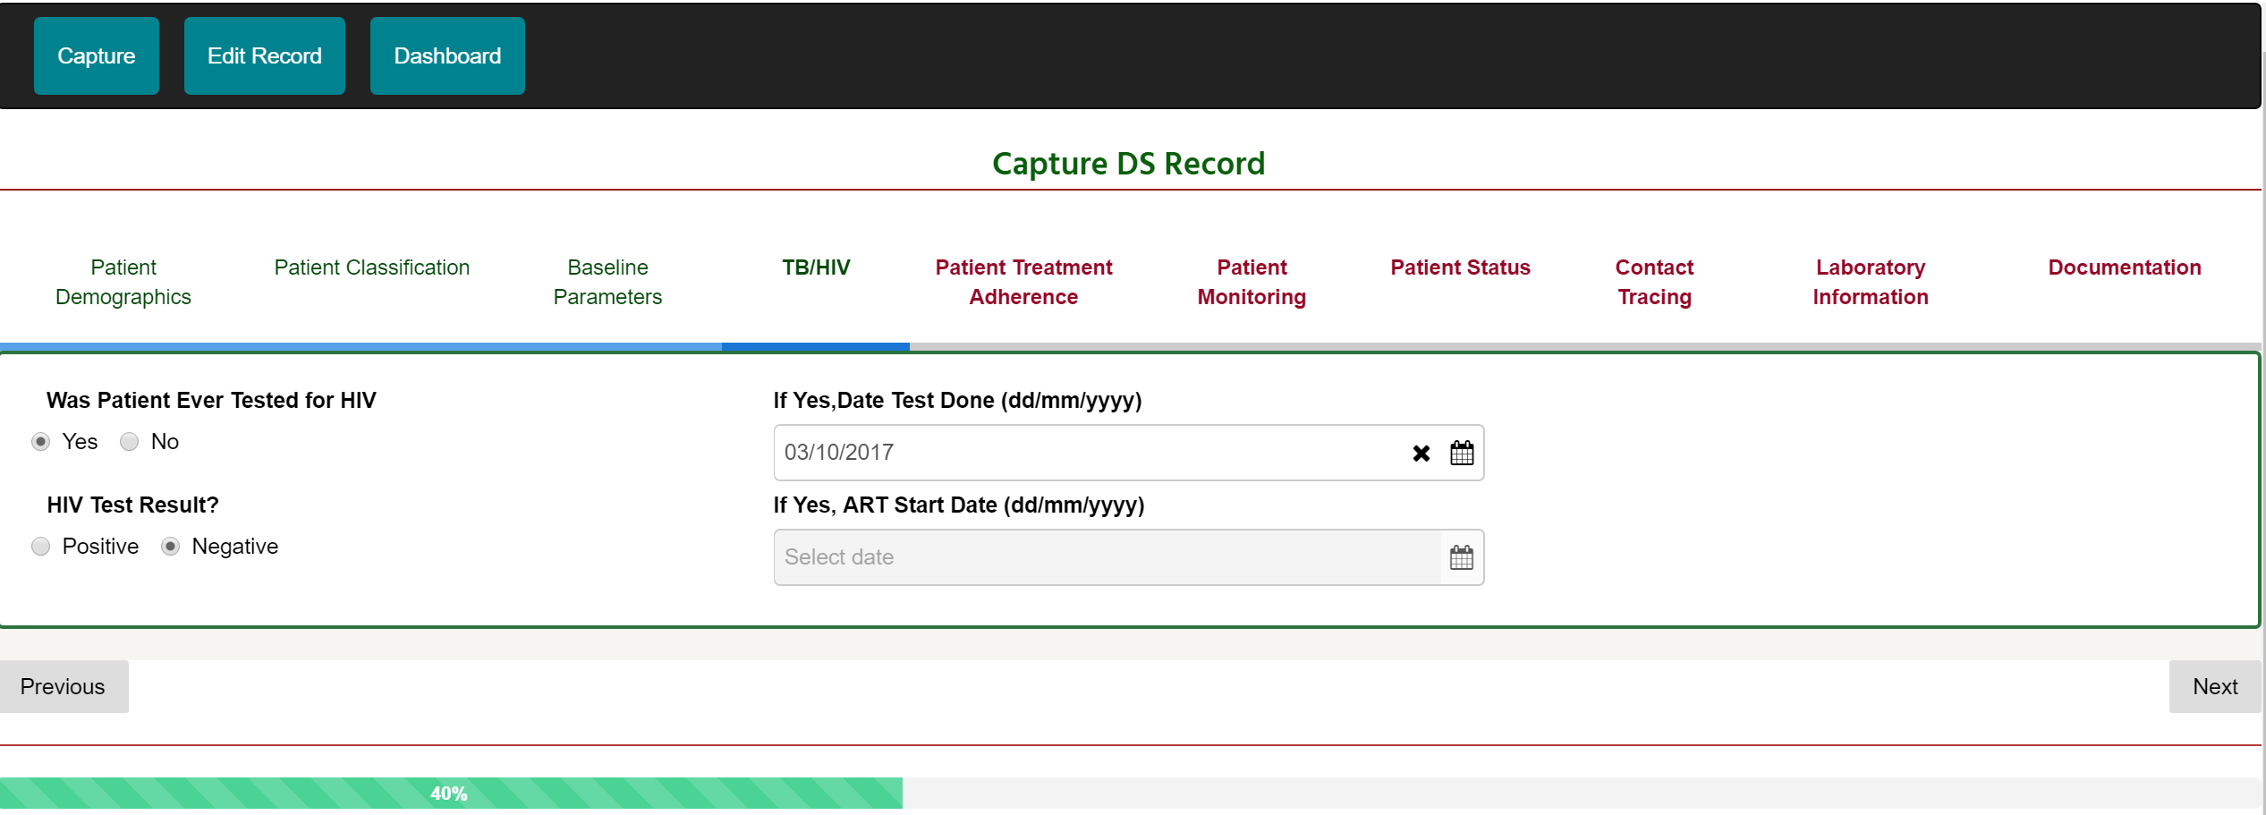
- The TB/HIV tab collects HIV-related information. Select the appropriate option and click on the “Next” button.
- On the “Patient Treatment Adherence” tab, enter the required data where appropriate and click “Next.”
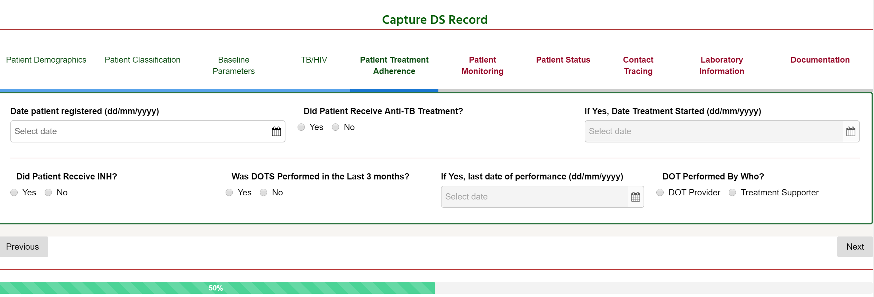

- On the “Patient Monitoring” tab section, enter follow up examination data for “Month 2,” “Month 5,” and “Month 6” and the corresponding “weight” and “drug intake” data.
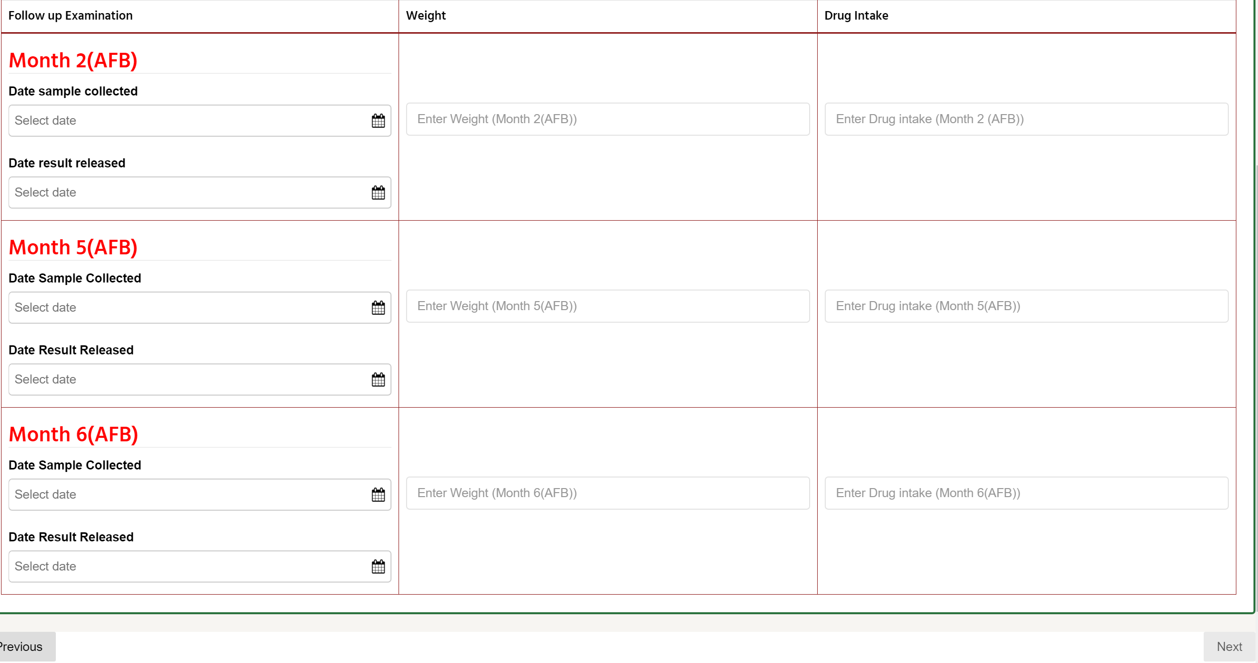
- Click the “Next” button.
Please Note: data has to be filled for each of the month categories to be able to proceed to the next tab.
- The “Patient Status” tab captures information about the patient status and treatment outcome during the review period.
- Select options in the appropriate category and click on the “Next” button.
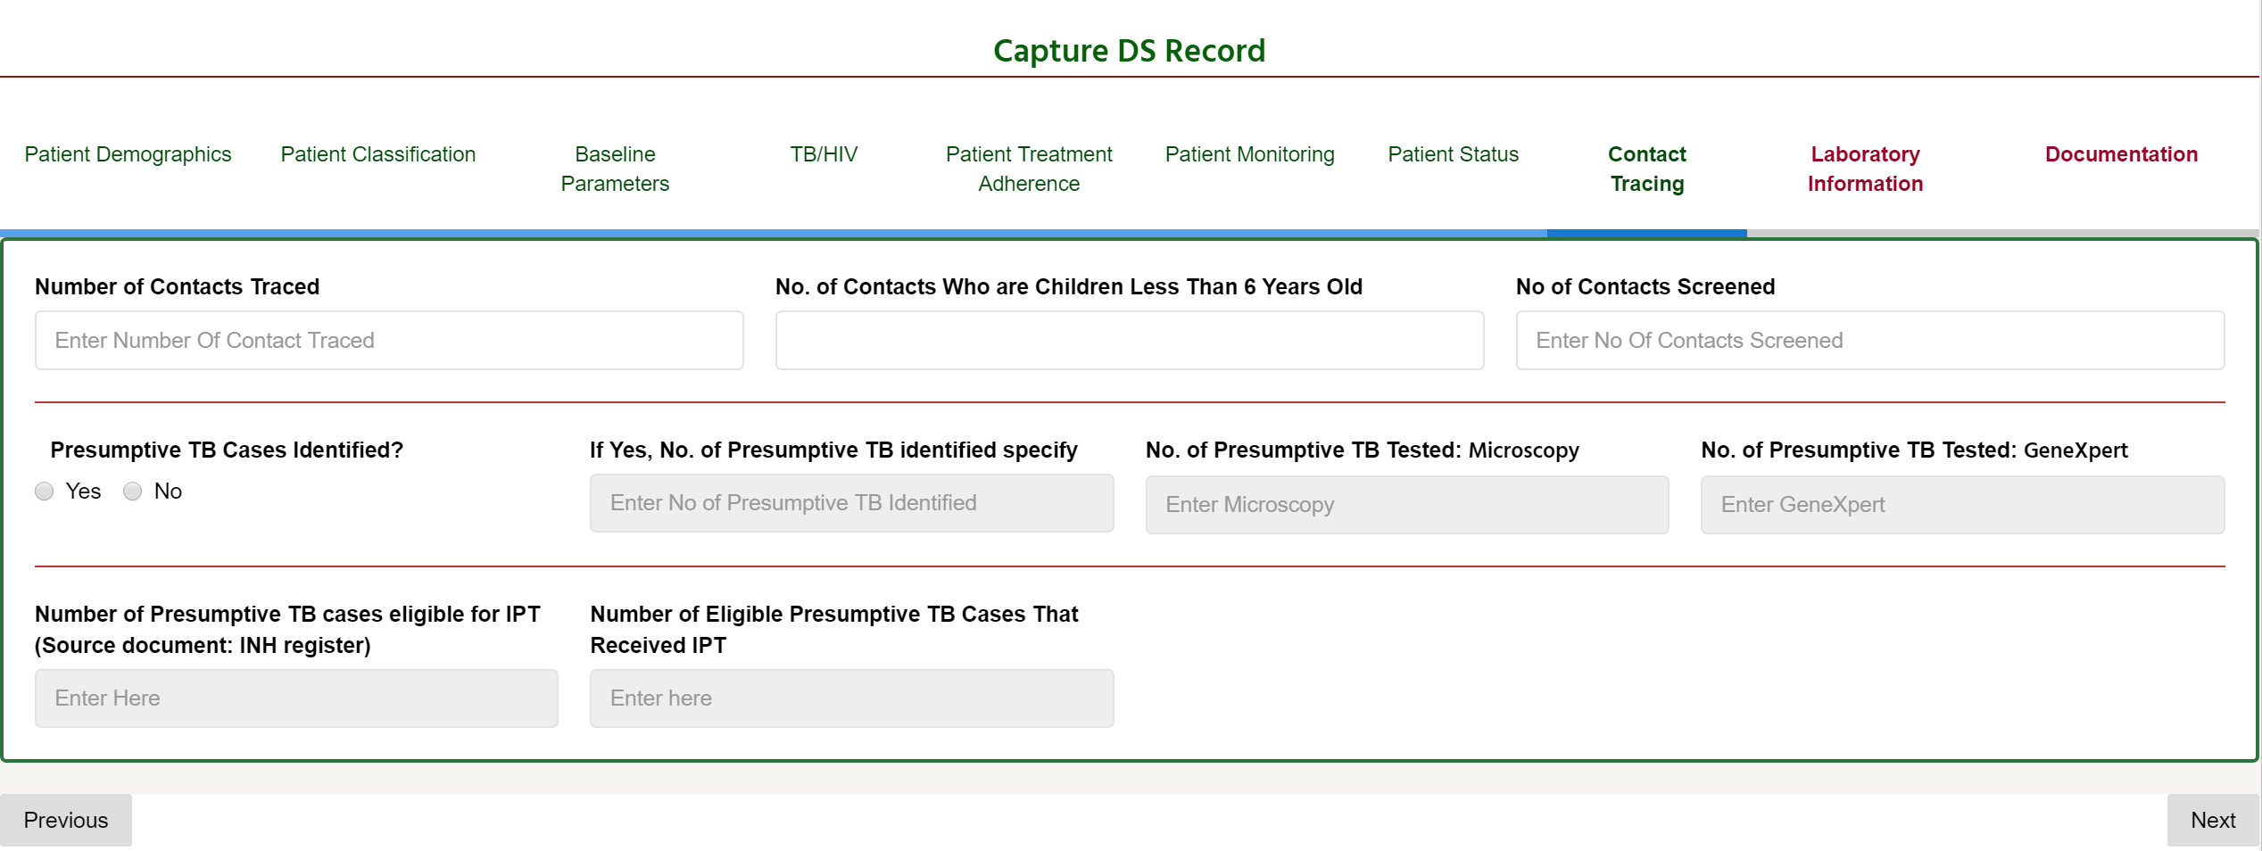
- “Contact Tracing” captures data about the number of contacts traced to the patient. Enter appropriate data into the required field (or click the appropriate radio button) and click on the “Next” button.

- “Laboratory Information” collects lab information about the patient. Enter data where required and click “Next.”
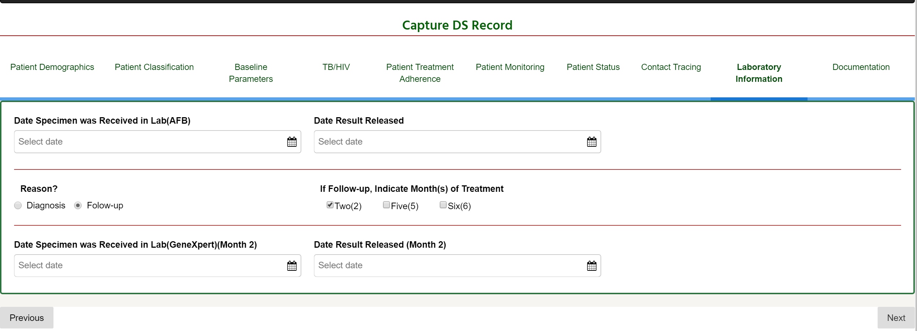
- The “Documentation” tab collects data necessary for this software. Select the appropriate radio button and click “Done.”
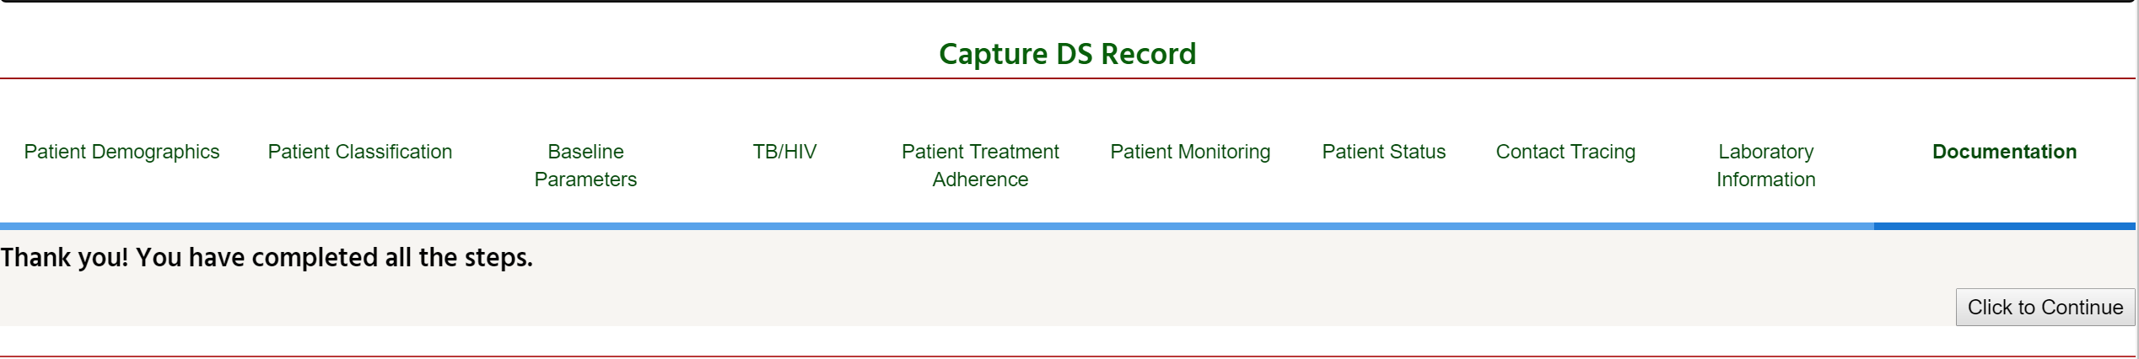
- Click “Click to Continue” button to enter the full patient record.

DRUG RESISTANT TUBERCULOSIS (DR_TB) EVALUATION AREA
To access the DR_TB evaluation area on the dashboard such as the one below:
- Click on the “DR Capture” icon and the DS_TB evaluation area appears.
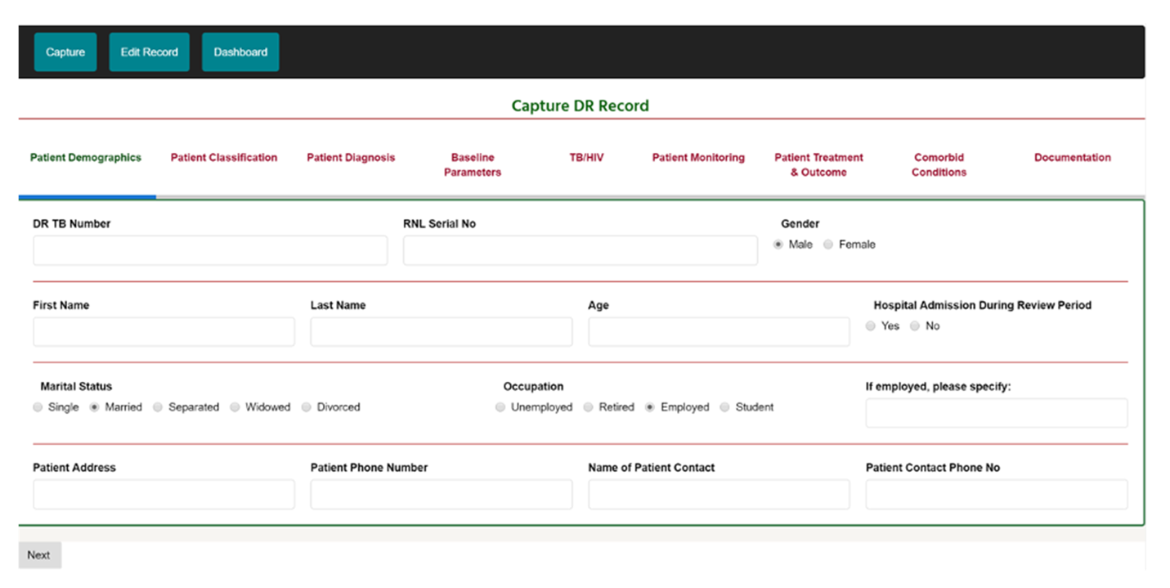
- Enter data into all fields in the “Patient Demographics” tab and click “Next” to move to the next (Patient Classification) tab.
Please Note: All fields are compulsory EXCEPT RNL serial number, hospital admission during review period, patient address, and name of patient contact. If mandatory fields are not filled, you can’t proceed to the next page.

- On clicking the “Next” button, the ensuing tab is “Patient Classification.” All categories in this tab are required.
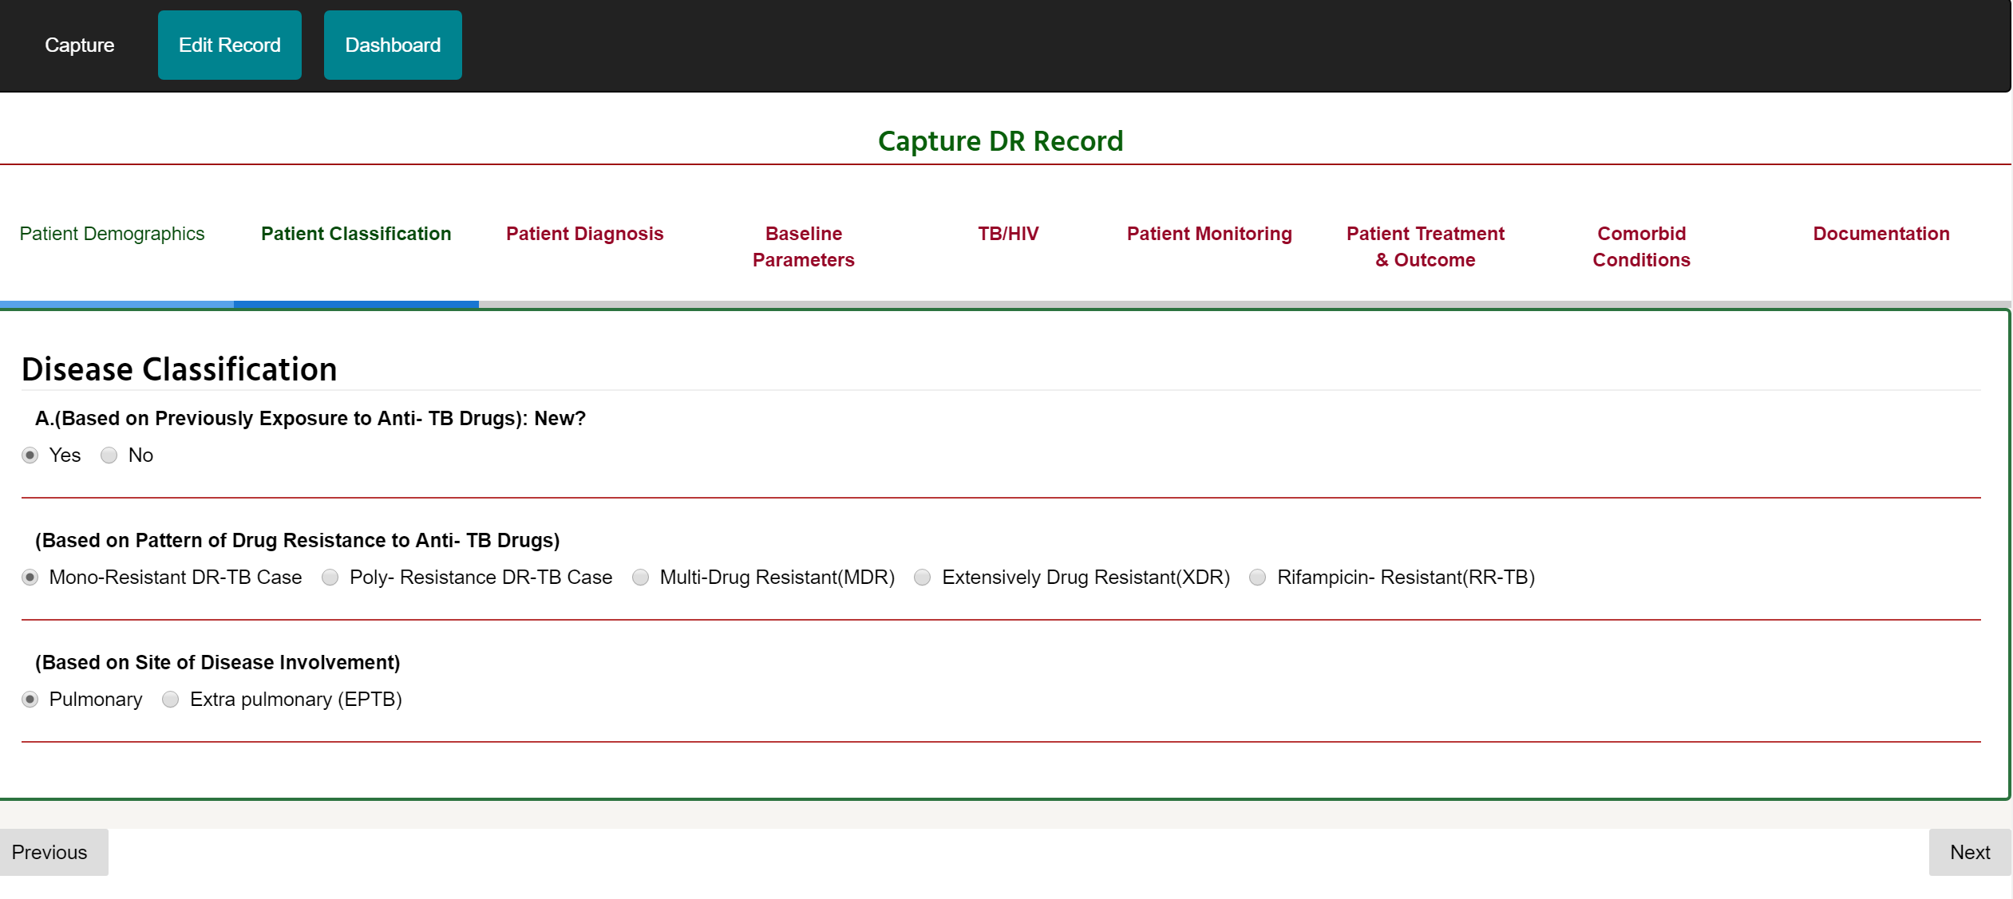
- Select the required radio button and click on the “Next” button.
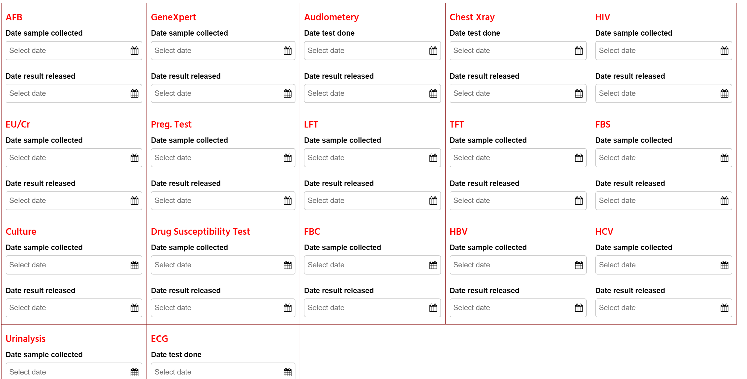

- In the “Baseline Parameters” tab, you are required to enter the “Date Sample Collected” and “Date Result Released” for all samples/tests completed, where applicable. Click on the “Next” button when finished.
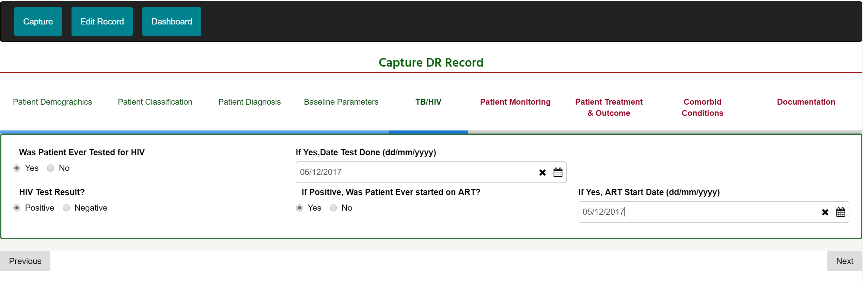
- The TB/HIV tab collects HIV-related information. Select the appropriate option and click on the “Next” button.
- In the “Patient Monitoring” tab, enter required data for “Date Sample Collected” and “Date Result Released.” You are required to enter data for all the samples/test taken for months 1–6.
- Click the “Next” button.
Please Note: data has to be filled for each of the month categories to be able to proceed to the next tab.
- The “Patient Treatment & Outcome” tab captures information about the patient’s treatment and the outcome recorded. Enter the relevant data/options and click the “Next” button.
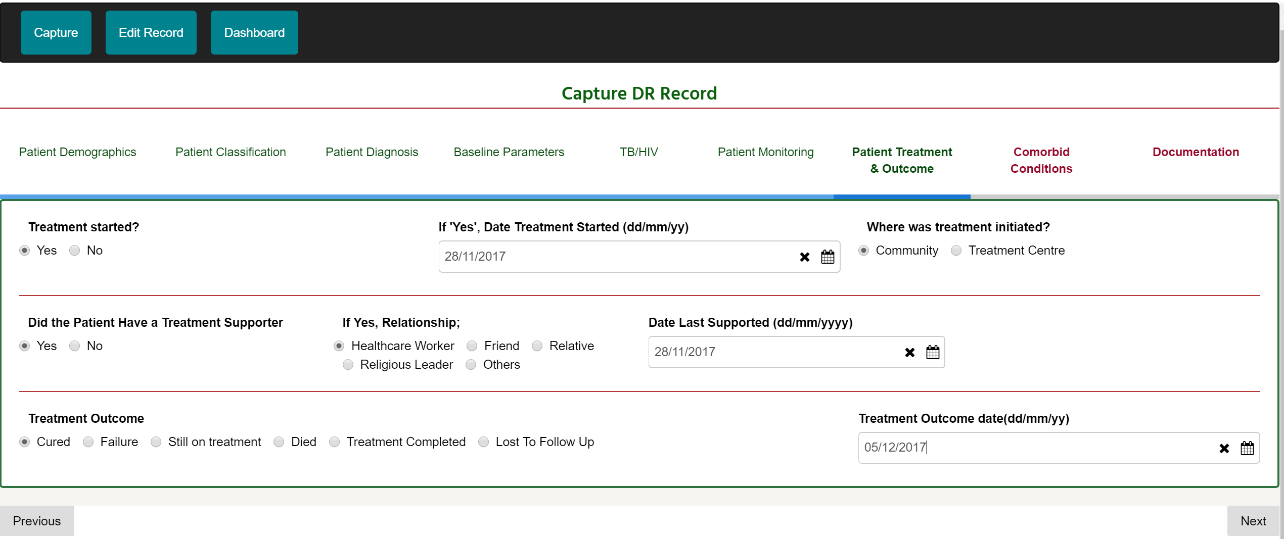

- “Comorbid Conditions” records other medical conditions that co-occurs with DR_TB. Select all that apply and click on the “Next” button.
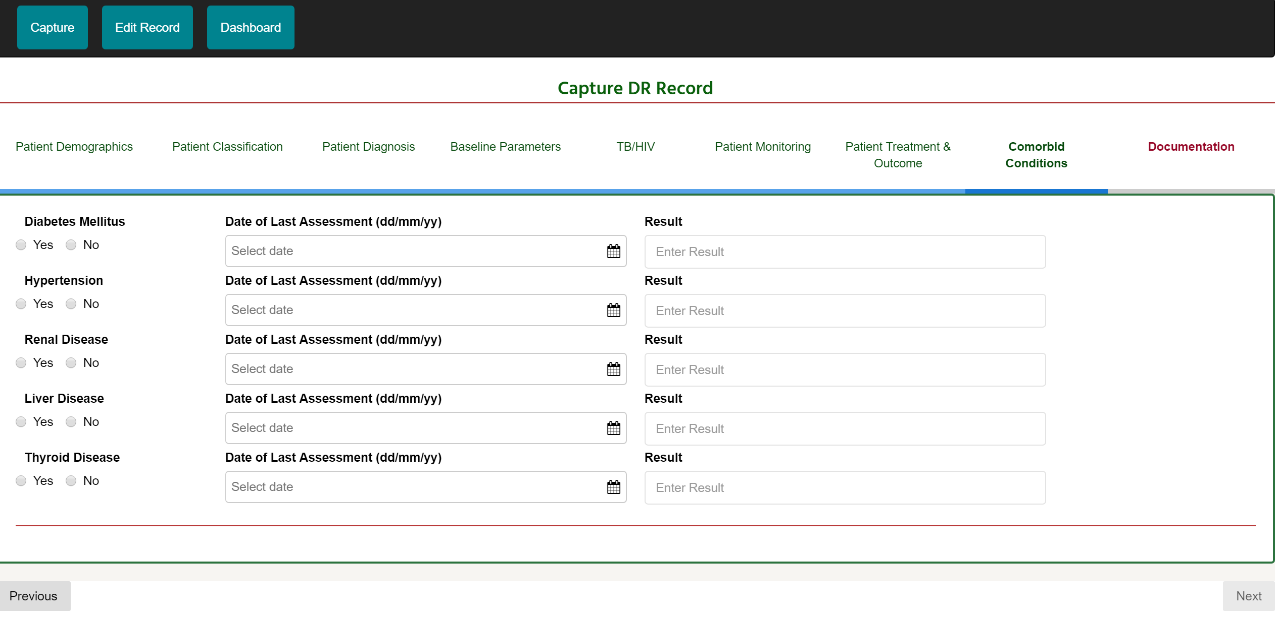
- The “Documentation” tab collects documented data necessary for this software. Select the appropriate radio button and click “Done”.
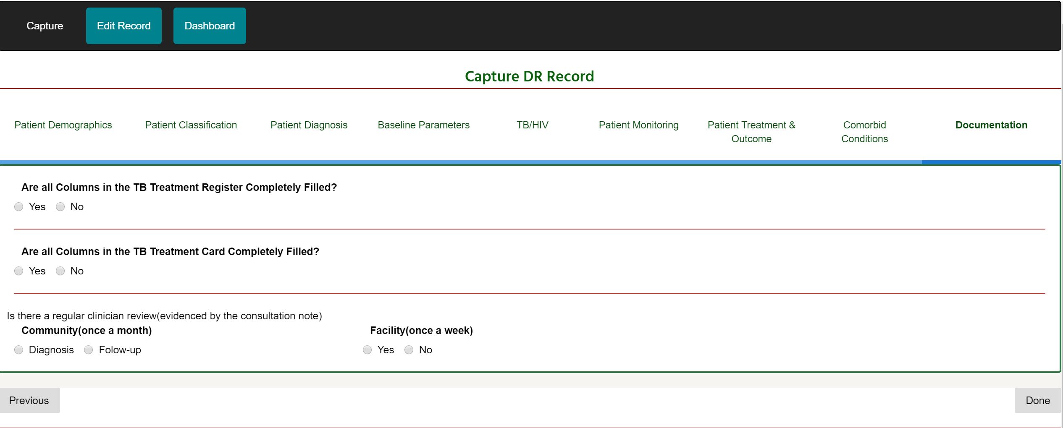

- On the next page that appears, click “Click to Continue” button to enter the full patient record.

PEDIATRICS TUBERCULOSIS EVALUATION AREA
To access the Pediatrics_TB evaluation area on the dashboard such as the one below:
- Click on the “Pediatrics Capture” icon and the DS_TB evaluation area appears.
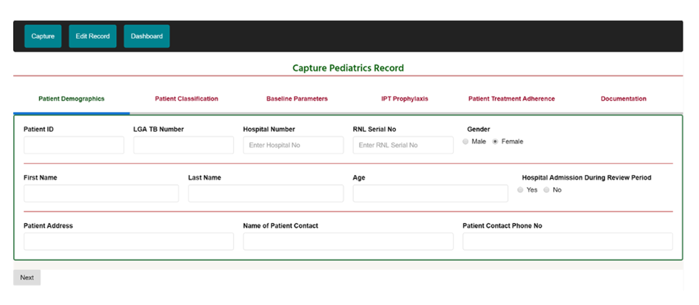
- Enter data into all fields in the “Patient Demographics” tab and click “Next” to move to the next tab.
Note: All fields are compulsory EXCEPT RNL serial number, hospital admission during review period, patient address, and name of patient contact. If mandatory fields are not filled, you can’t proceed to the next page.

- On clicking the “Next” button, the ensuing tab is “Patient Classification.” All categories in this tab are required.
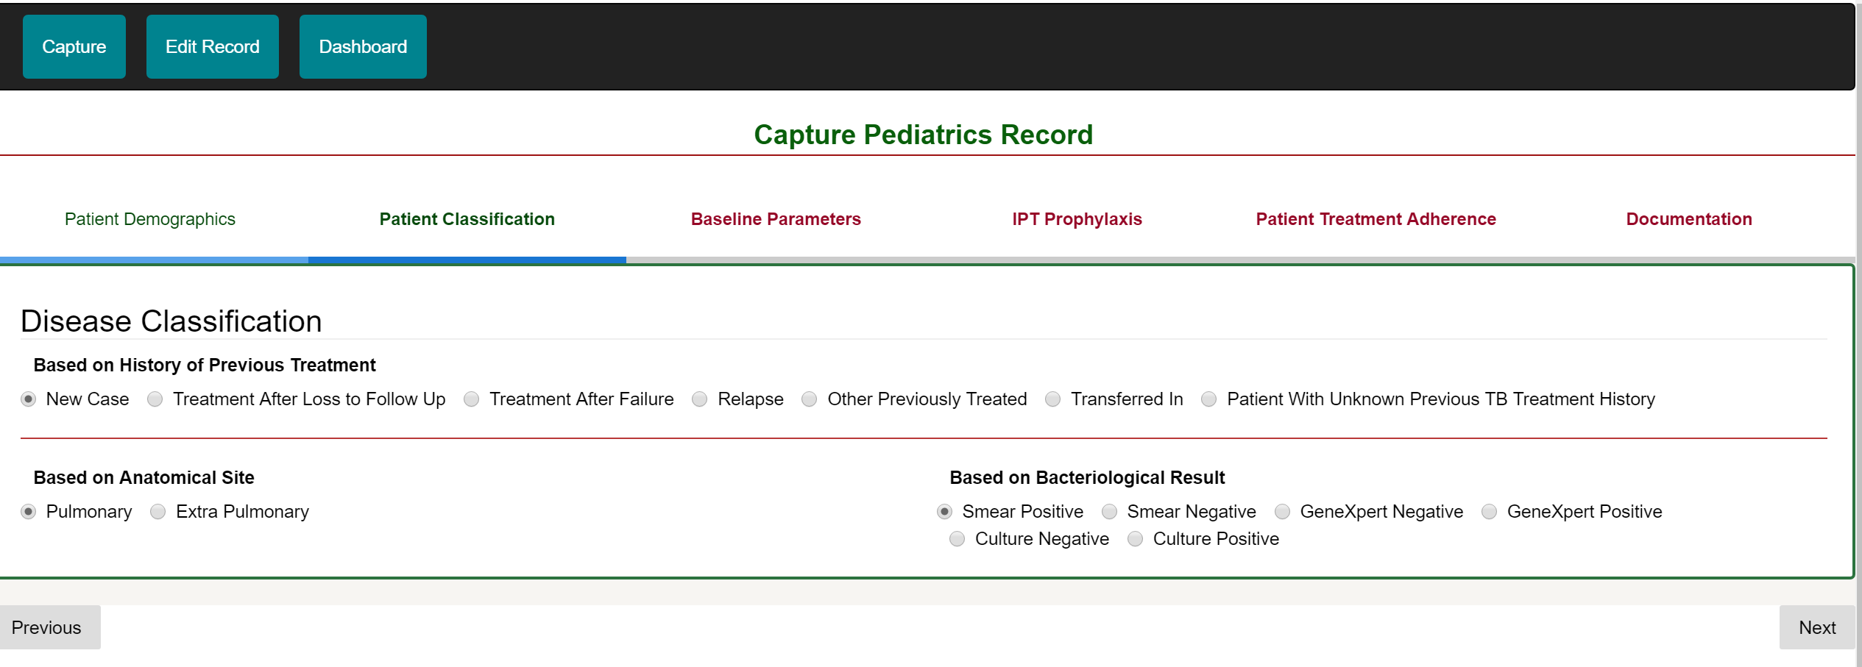
- Select the appropriate radio button and click on the “Next” button.
- In the “Baseline Parameters” tab, select options for fields where applicable. If “Yes” is selected for “Was the Child a Presumptive TB Case,” then the following fields are mandatory: “Historical Finding in Child,” “Physical Finding,” “Weight,” and “Weight Date.” If “No” is selected, then “Weight” and “Weight Date” fields are required.
- Click the “Next” button.
- In the “IPT Prophylaxis” tab, select options that apply to the patient record being entered and click the “Next” button.
- The “Patient Treatment Adherence” tab is about the degree to which the patient correctly follows medical advice. Enter the relevant data and click on the “Next” button.
- The “Documentation“ tab tracks how the treatment card and register are filled. Select the appropriate options in the field provided and click on the “Done” button.
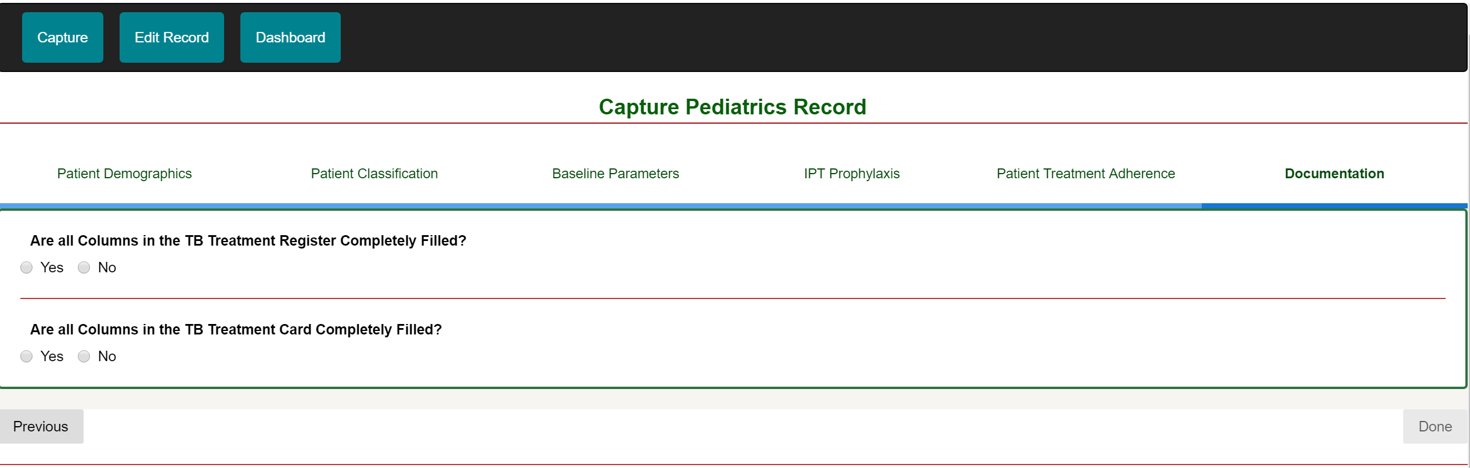
- Click on the “Click to Continue” button to enter subsequent records into the pediatric evaluation area.

NON-CLINICAL EVALUATION AREA
The non-clinical evaluation area evaluates areas other than the clinical processes of TB at the treatment sites. Let’s take a walk through the non-clinical evaluation area.
To navigate to this evaluation area from the dashboard, click on the icon with the “Non-Clinical Capture.”
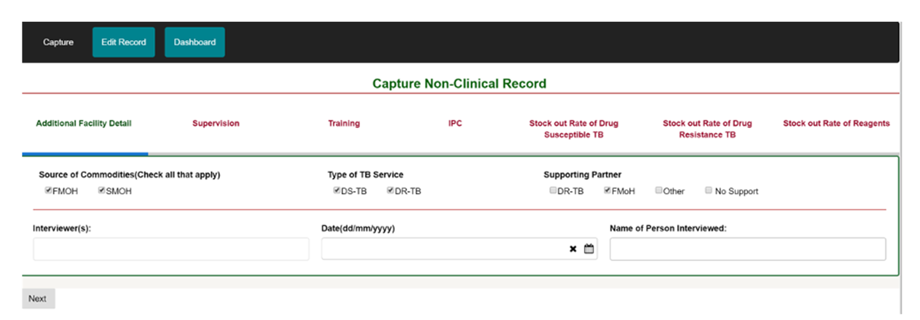
- On the “Additional Facility Detail,” click on the appropriate options for all categories and click on the “Next” button.
- The “Supervision” tab captures data that revolves around the general overseeing of what goes on in the facility. Select all appropriate options and click on the “Next” button.
- “Training” keeps tab about capacity building of the facility staff. Enter appropriate data and click on “Next.”
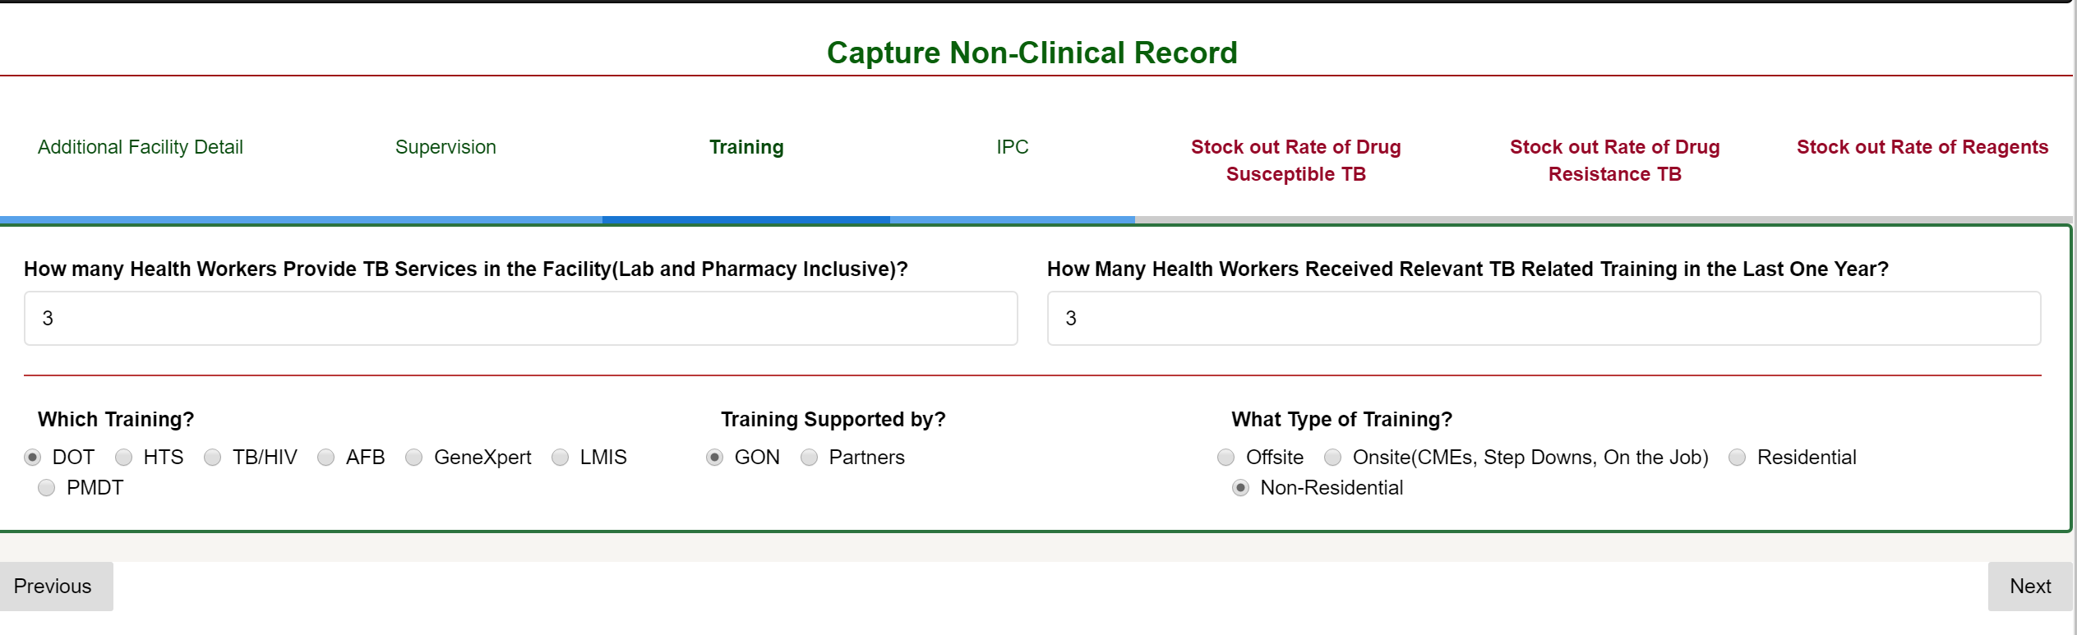
- In the “IPC” tab, check the appropriate button for the various categories and click on “Next.”
- The “Stock Out Rate of Drug Susceptible TB,” “Stock Out Rate of Drug Resistant TB,” and “Stock Out Rate of Reagents” tabs keep track of the drugs or reagents in the facility. Select the appropriate option for the drugs or reagents and click “Next” or “Done.”

REPORT GENERATION
When the data for a treatment site is captured, the results for indicators in each evaluation area is generated at the facility level. To view the report generated, do the following:
- Click on the dashboard tab.
- Select the “General Report” icon and on the page that appears.
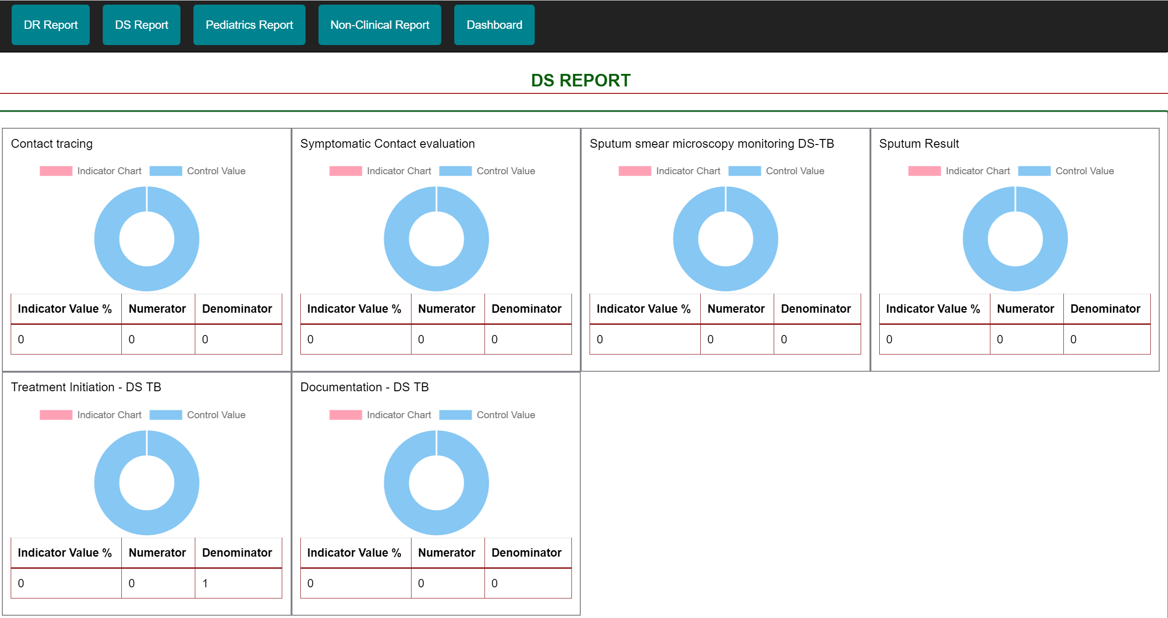
- Click on the report you want generated and all indicators for that evaluation area to be displayed.
- Do the same for all evaluation areas to be viewed.

MANAGING UPLOADS
The manage uploads menu is responsible for uploading the records entered into the software to the web portal. When an upload is completed, the status (if successful or not) of the uploaded records can be viewed.
To upload records entered:
- Click on the “Manage Users” icon and the page like the one below appears
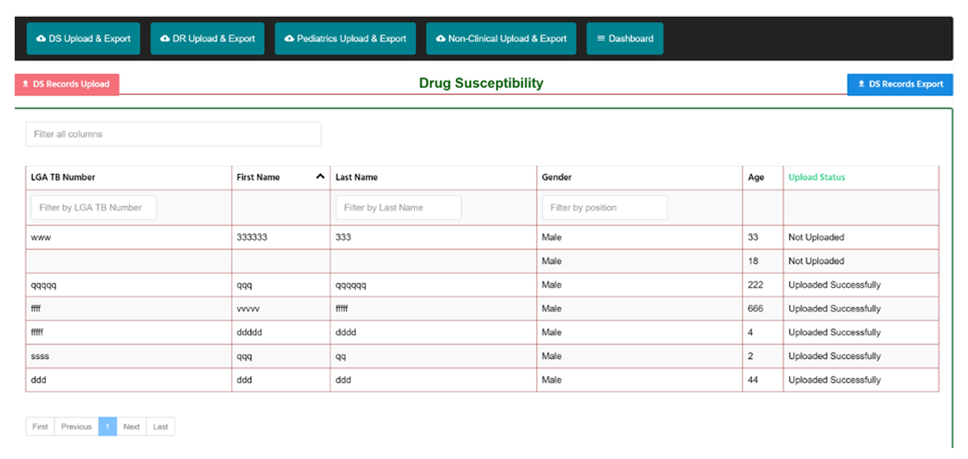
- Select the evaluation area (DS Upload&Export, DR Upload&Export, Pediatrics Upload&Export, or Non-Clinical Upload&Export) to be uploaded.
- On the upper left-hand side of the page, click on the “DS Records Upload” to upload all records captured for the DS evaluation area. (Do the same for all other evaluation areas).

