

Center for Advanced Imaging Research (CAIR)
Imaging Science Seminar Series

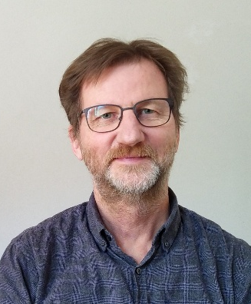
Roland Kreis, PhD
Professor
Magnetic Resonance Methodology
Institute of Diagnostic and Interventional Neuroradiology
University of Bern, Switzerland

The water signal in MR spectroscopy: nuisance or blessing?

Date: Tuesday, April 15, 2025
Time: 4:00 p.m.
Location: Frenkil Lecture Hall, Health Sciences Research Facility III
Zoom link is available for those who cannot attend in person:
https://umaryland.zoom.us/j/93487148870
Faculty Host: Thomas Ernst, PhD

Abstract: In proton spectroscopy water surmounts all metabolite signals by a factor 3000 to a million. Hence, it is usually suppressed for spectroscopy acquisitions. In this presentation some of the reasons why one might want to handle the water magnetization differently are presented. They range from water serving as reference for phase, frequency and amplitude fluctuations to water allowing longitudinal relaxation enhancement and observation of otherwise unobservable metabolites.

