

Center for Advanced Imaging Research (CAIR)
Imaging Science Seminar Series

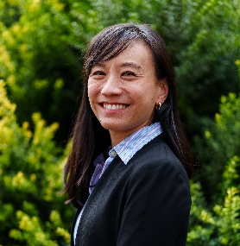
Audrey Fan, PhD
Assistant Professor
Departments of Neurology and Biomedical Engineering
University of California, Davis

MRI of cerebrovascular dynamics as a window into brain function and health

Date: Thursday, April 3, 2025
Time: 11:00 a.m.
Location: Frenkil Lecture Hall, Health Sciences Research Facility III
Zoom link is available for those who cannot attend in person:
https://umaryland.zoom.us/j/97600656211
Faculty Host: Peiying Liu, PhD

Abstract: The human brain depends on continuous blood flow to deliver the oxygen and nutrients it needs to function. Disruption to this oxygen supply has devastating consequences, not only in cerebrovascular disease but in many neurodegenerative and psychiatric disorders. A major research goal of our group is thus to develop non-invasive imaging methods to understand brain vascular dynamics in health and disease.
In this talk, I describe wavelet coherence analysis to understand how functional MRI signals in different brain networks are linked to systemic physiology (heart rate, respiration), using Human Connectome Project data. I also describe measurement of cerebrovascular reactivity - the brain's vascular response to external stimuli - in aging and development using fMRI signals. Finally, I propose a novel dynamic vascular MRI "fingerprinting" approach that uses rapid, gradient-and-spin-echo scans to map brain physiological parameters every 5 seconds. Together, these tools provide insight into the brain’s vascular responses during normal function and as a potential early physiological marker of neurological dysfunction.

