

Center for Advanced Imaging Research (CAIR)
Imaging Science Seminar Series

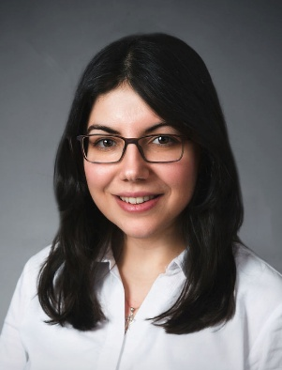
Luana Colloca, MD, PhD, MS
Professor
Department of Pain and Translational Symptom Science
MPower Professor of the University of Maryland Strategic Partnership
Director, Placebo Beyond Opinions Center
University of Maryland School of Nursing

Pain, Perception, and Placebos: Rethinking the Aging Brain

Date: Friday, June 12, 2026
Time: 12:00 – 1:00 p.m.
Location: Frenkil Lecture Hall, Health Sciences Research Facility III
Zoom link is available for those who cannot attend in person:
https://umaryland.zoom.us/j/91019414322
Faculty Host: Thomas Ernst, PhD

Abstract: Chronic pain has been linked to accelerated brain aging, often quantified as the brain-age gap (BAG), the difference between chronological and neuroimaging-derived brain age. We examined whether brain aging affects pain severity and endogenous pain modulation in individuals with temporomandibular disorder (TMD) compared to matched healthy controls.
Using machine- and deep-learning models applied to structural MRI data, we found that individuals with TMD showed older estimated brain age. Greater brain age was associated with higher pain severity, interference, and likelihood of high-impact pain, and mediated the relationship between chronological age and pain outcomes.
Together with additional brain imaging analyses, these findings suggest that while accelerated brain aging relates to worse clinical pain, endogenous modulatory processes such as placebo effects remain preserved, underscoring their therapeutic potential across the lifespan.

