Registering for Multifactor Authentication (MFA) using Duo

The University of Maryland School of Medicine (SOM) requires MFA to access SOM resources while off campus. SOM is partnered with Duo to provide MFA services. In order to use Duo, you must register with the service by following the below procedure. Please note: First time Duo registration can occur on/off campus. Subsequent logins will only require Duo when off campus

- Sign in to Office 365 (https://portal.office.com). When your credentials are entered, you’ll be prompted to setup Duo.
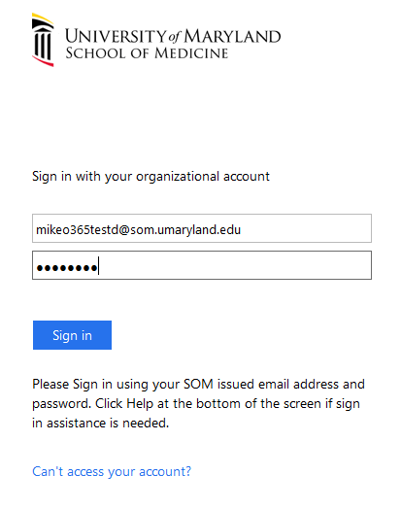
- Click “Start Setup”. Declare the type of device you’re setting up (smart phone recommended), and enter the device phone number. (Note: If a Duo screen doesn’t appear you may have already enrolled. Confirm by performing off campus. If you still aren’t prompted for Duo registration, please contact your Help Desk).
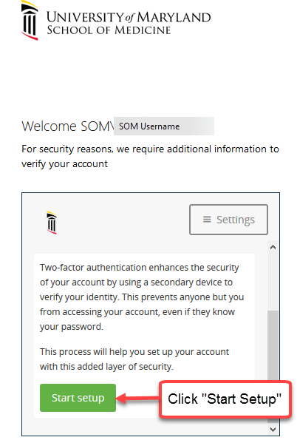
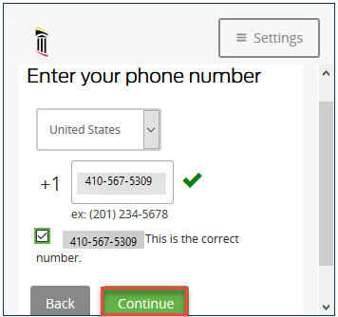
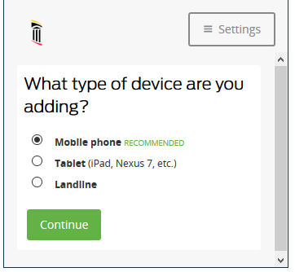

- Verify Device by choosing “Text or Call Me”. Enter the 6 digit code you receive in the box and click Continue.

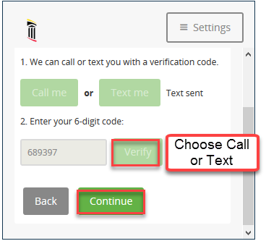

- Choose your device type and install Duo Mobile from the applicable store.. Activate using the QR Code provided.

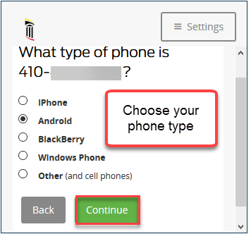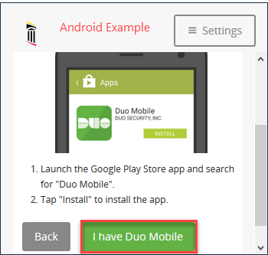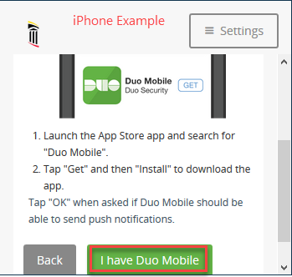
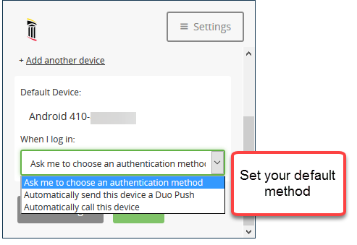
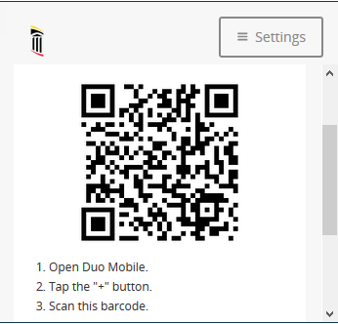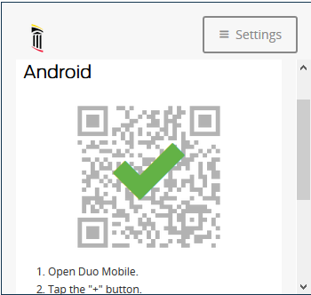
**Helpful hint: If you want Duo to just always either send you a Duo Push to your smartphone or automatically call your phone for the 2nd factor authentication, choose it here to save a “click” and time on subsequent logins.

- Sign into Office 365 using your enrolled device.
Select “Send me a Push” to approve through Duo app (recommended), “Call Me” or “Enter a Passcode” and request a Text message from Duo.

